**Project 1.1:**

**Checking list of files in Hadoop.**

**Hadoop fs –ls /hadoopdata.**



**Created folder acadgild mini project .**

**Hadoop fs –ls /hadoopdata/aminiproject.**



**Imported Crimes.csv file into agminiproject.**

**Hadoop fs –ls /hadoopdata/aminiproject/Crimes.csv**



**For showing data in Crimes.csv file**

**Hadoop fs –cat /hadoopdata/aminiproject/Crimes.csv**

**1. Write a MapReduce/Pig program to calculate the number of cases investigated under each**

**FBI code**

**Using Pig :**

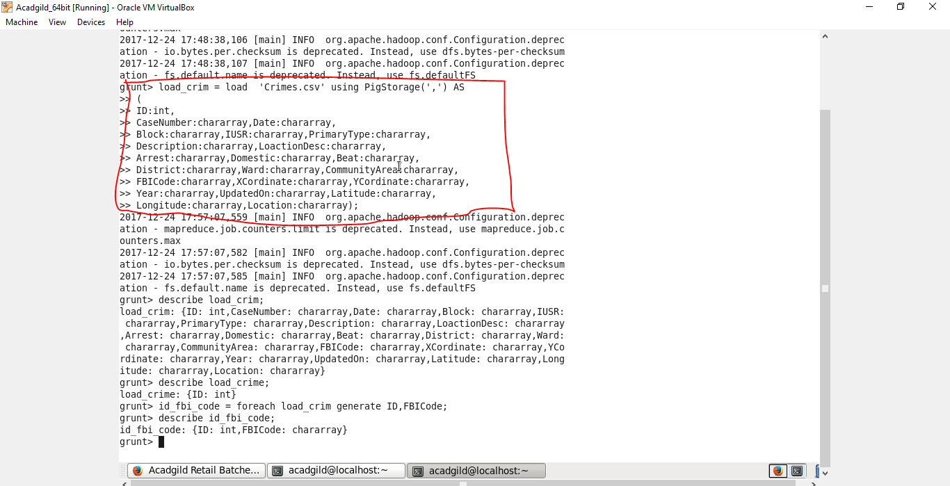

**Loading in fbi code:**

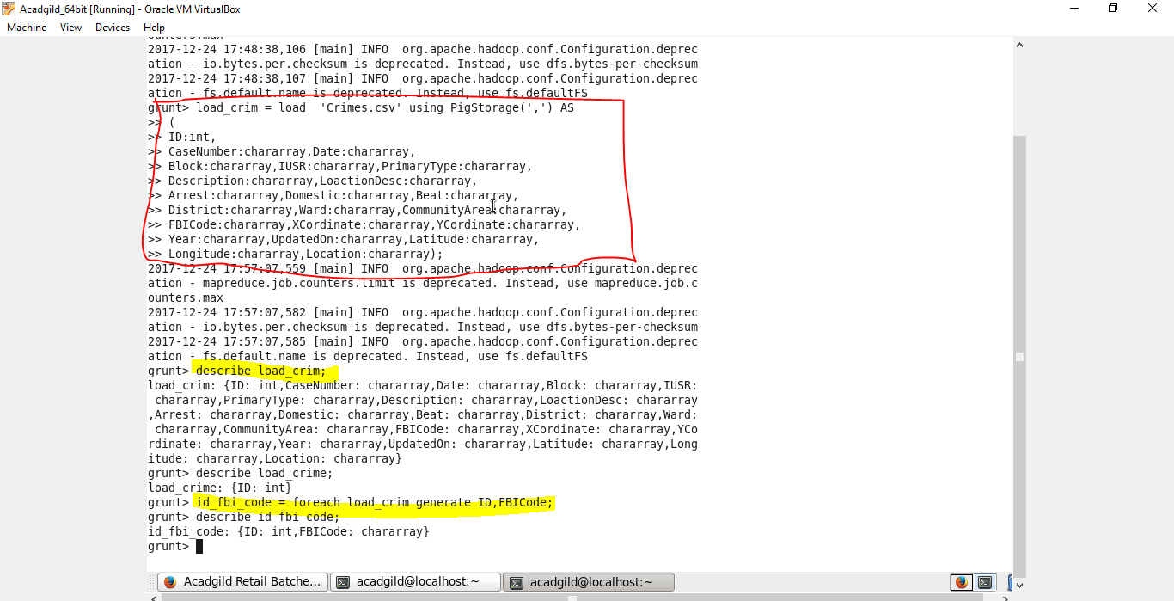

**Grouping the fbi code by using fbi code:**

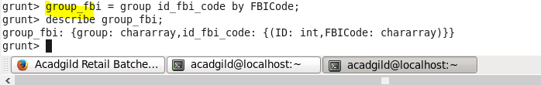

**After dumping data above group_fbi:**

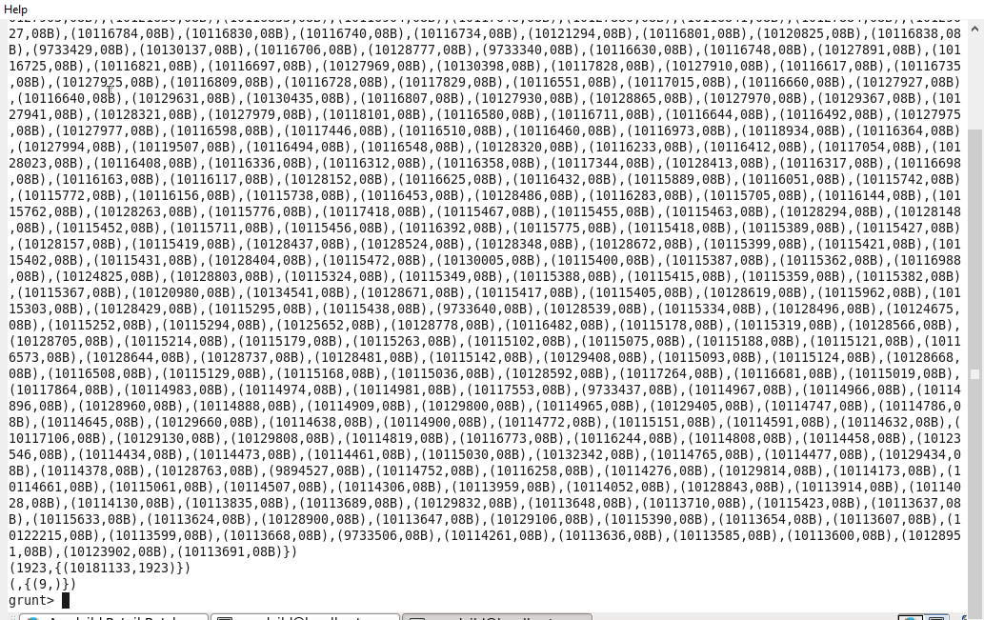



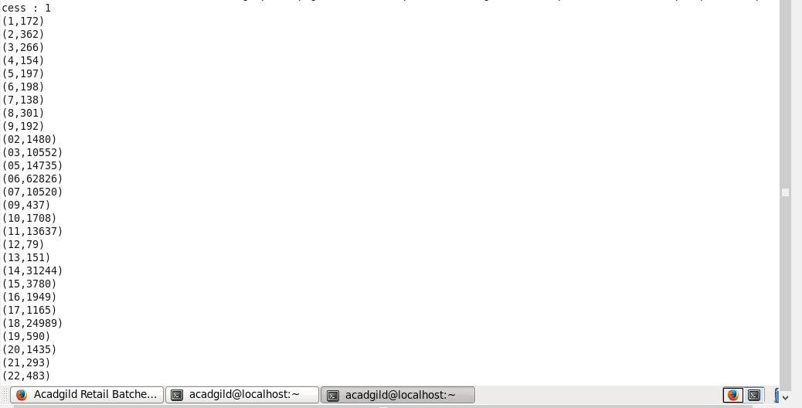

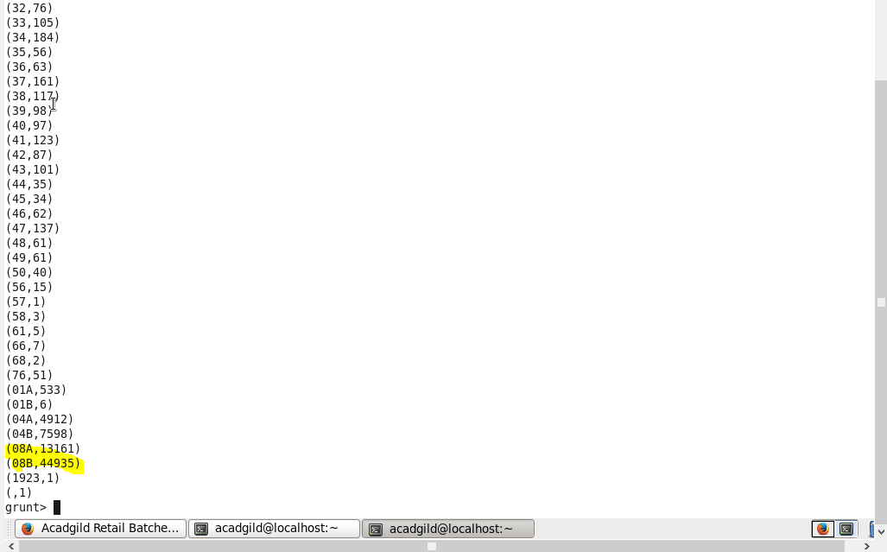

**2. Write a MapReduce/Pig program to calculate the number of cases investigated under FBI**

**code 32.**

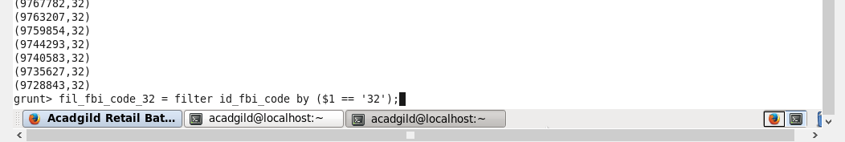

**Dumping data in**

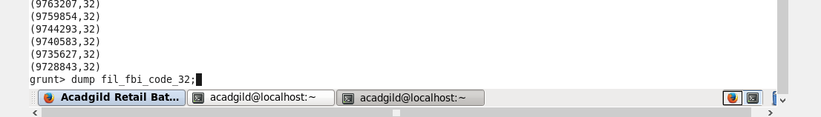

**After dumping data:**

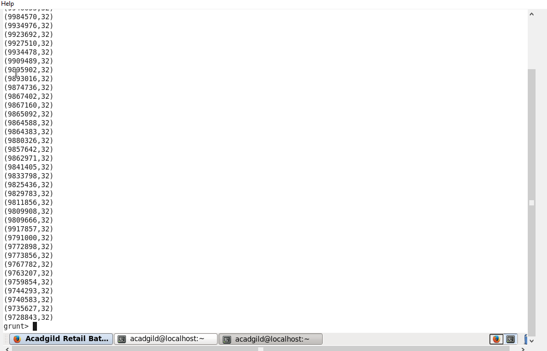

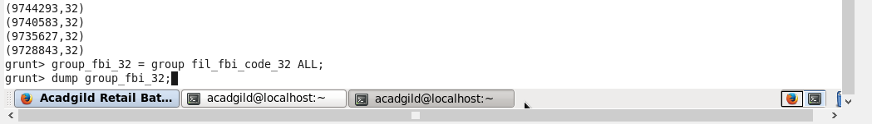

**For counting investigated FBI code under 32.**

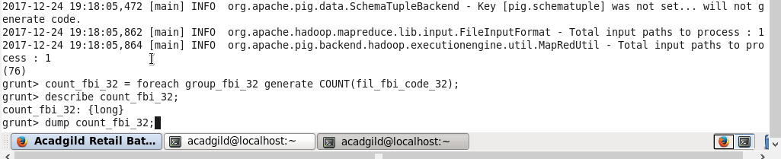

**3. Write a MapReduce/Pig program to calculate the number of arrests in theft district wise.**

Step - 1

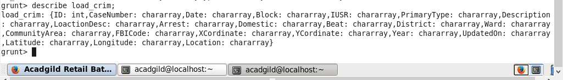

Step – 2 : filter only THEFTS records.

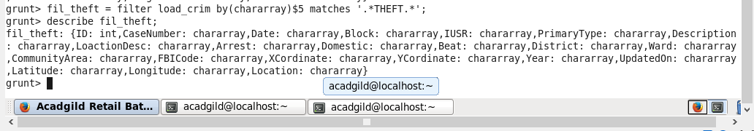

Step – 3 : grouping with respect to district:

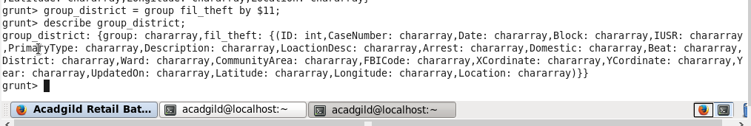

Step – 4 grouping each district wise:

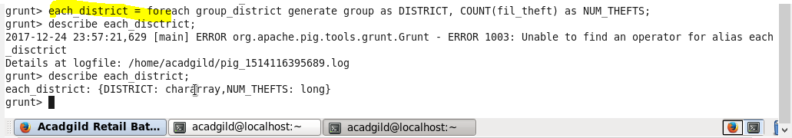

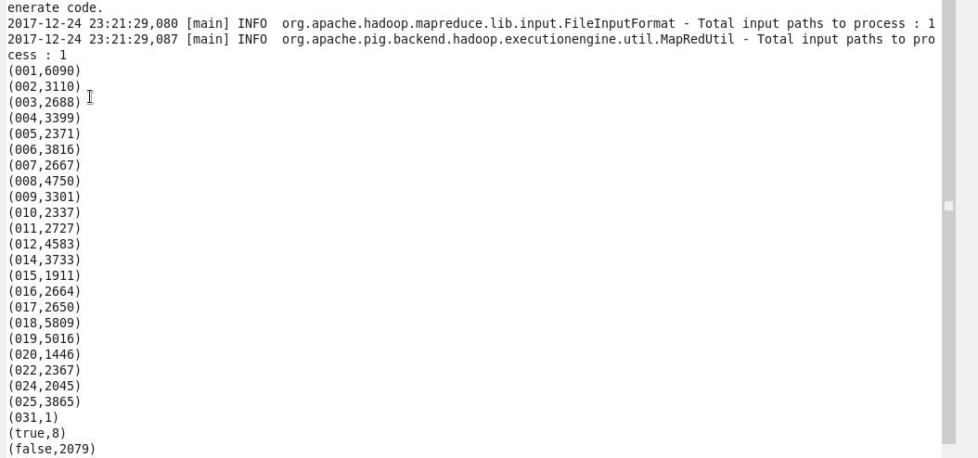

**4. Write a MapReduce/Pig program to calculate the number of arrests done between October**

**2014 and October 2015.**

**Filtering records in between 2014 and 2015;**

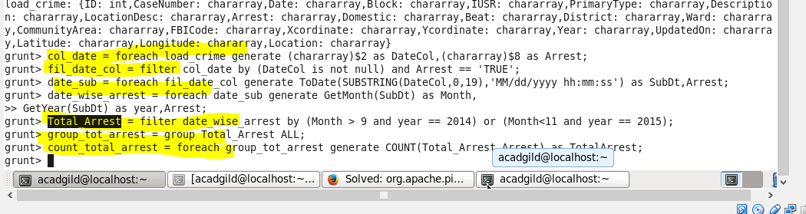

**Selecting columns:**

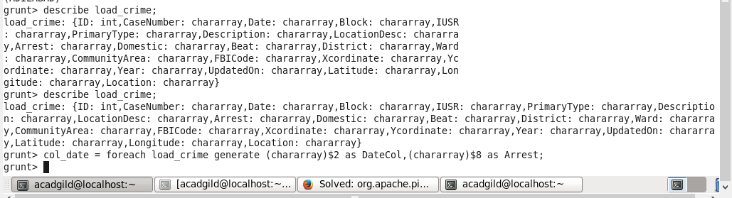

**Data dumped on col_date:**

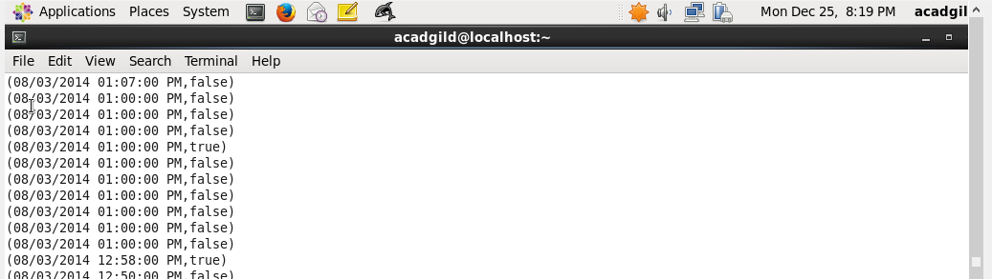

**Filtering from above selected columns:**

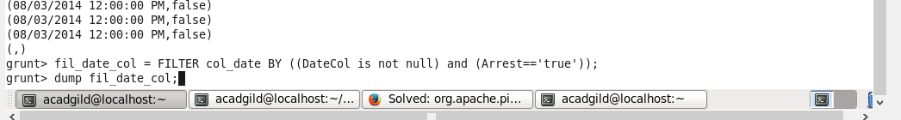

**After dumping :**

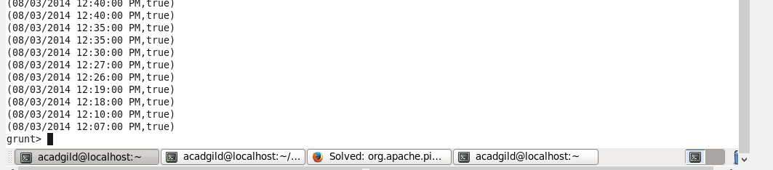

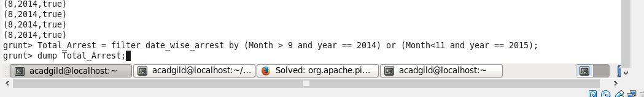

**After dumping data:**

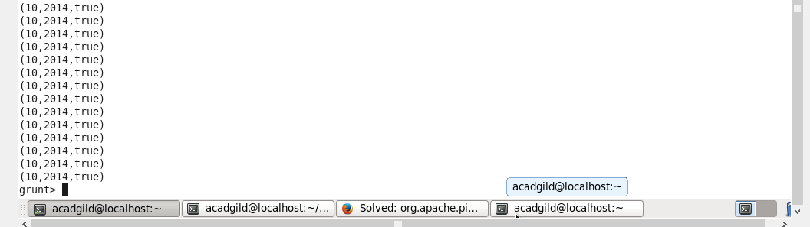**Grouping by using Arrest :**

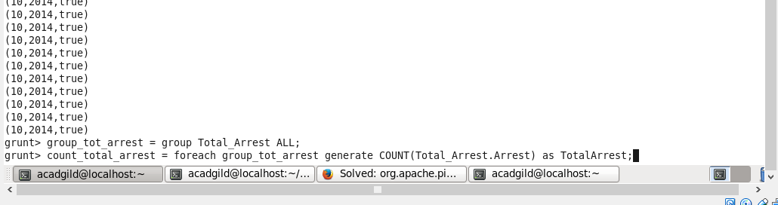

**After counting total arrest :**

